STEP BY STEP ENTRYBOSS REFUND GUIDE

- Login to your EntryBoss Account
- Go to the right-hand corner and click ‘My Entries’
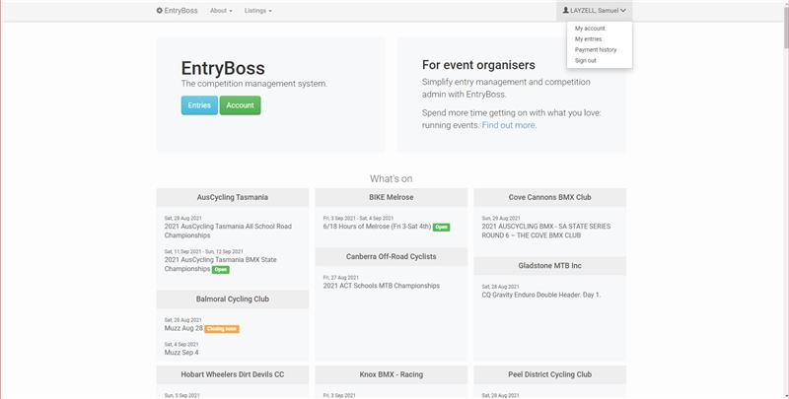

- Select ‘Bowral Classic Criterium’
- Select the Red ‘Scratch’ button on the event page on the right-hand side
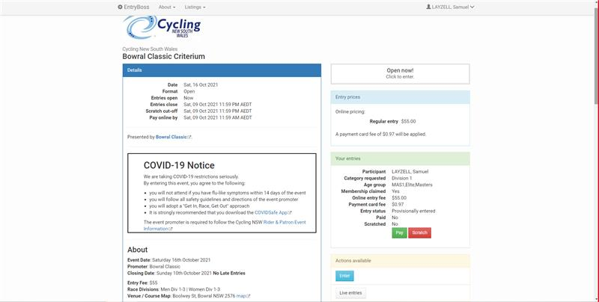
- A confirmation email will be sent to your email

